Installing VirtualBox and Setting Up The Virtual Machine

# Introduction

VirtualBox is freely available software which allows a user to run a virtual machine on their host computer, meaning that they can run, as we will, a Linux operating system on Windows or OSX. The virtual machine contains all of the software and data to be used during the course.

# Installation of VirtualBox

VirtualBox is available from this website:

<https://www.virtualbox.org/>

This virtual machine was setup using version 7.0.x of VirtualBox and we would recommend using this version

Please download the installer for the operating system of your computer and run through the installation process. **PLEASE NOTE:** admin rights to your computer are required to install VirtualBox.

After installation of VirtualBox, you should also install the VirtualBox extension pack, which is available on the same page. The installation process for this should start after download. The extension pack is not essential but does include many useful features e.g. the ability to attach a USB drive to the virtual machine.

Once VirtualBox and its extension pack are installed, running the software should open the main interface window.

**Download of the Virtual Machine**

The virtual machine is stored as one large zipped file of around 10 GB in size. Please download the image from here (Box > Laboratory Additional > VirtualBox Machines):

<https://path.box.com/s/sqat69f1m7tt5wu941ji14y9tvfzfnf9>

Download may take a long time due to the size of the file. We recommend using a resilient client such as FileZilla for downloads:

<https://filezilla-project.org/>

This means that, if the download halts briefly, it should resume from the point at which it stopped.

PLEASE NOTE: The downloaded file is compressed using zip. You will need to uncompress it before proceeding further.

**Setting Up the Virtual Machine**

Once the virtual machine file has downloaded successfully, you can set start to set the virtual machine up. To do so:

1) Click the New button as seen on the above screenshot.

2) This leads to a window similar to this:

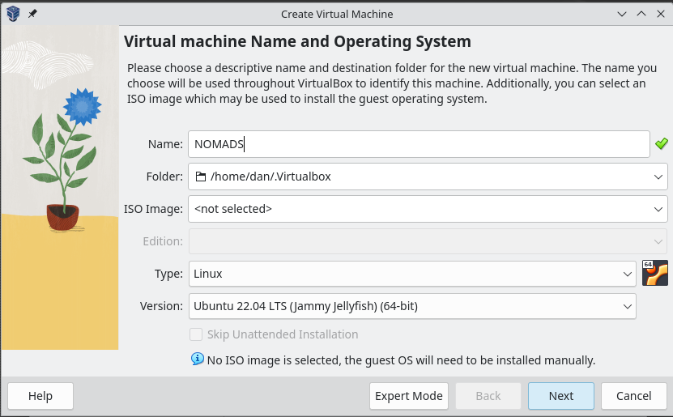

Give a name to your machine. This can be anything but it makes sense to name it with something meaningful e.g. ‘NOMADS’ (as above).

Next, set the Type to ‘Linux’ and the version to ‘Ubuntu 22.04 LTS (64-bit)’. Once done, click the Next button.

3) This leads to a window allowing you to set the memory (RAM) and the number of CPU’s allocated to the virtual machine:

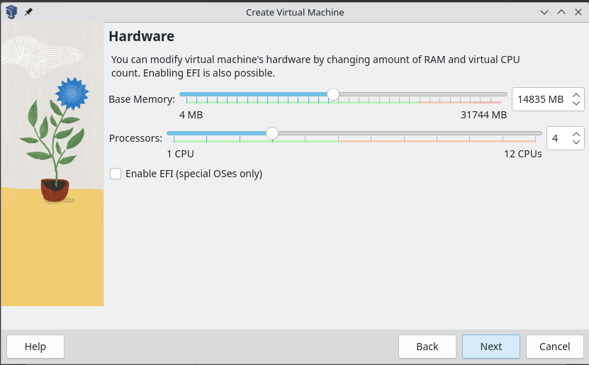

The amount of memory / CPUs you may allocate differs from machine to machine, depending on how much your computer has. For maximum performance set the memory / CPU so that it is close to the top end of the green part of the line, but not into the pink. Click the Next button.

4) The next thing to do is to move the virtual machine file you downloaded above into the newly created foilder for the new guest (in the above example, this will be in /home/dan/.Virtualbox/NOMADS). Once copied celect the ‘Use an existing virtual hard disk file’ and click the yellow and green icon to the right of the pulldown menu.

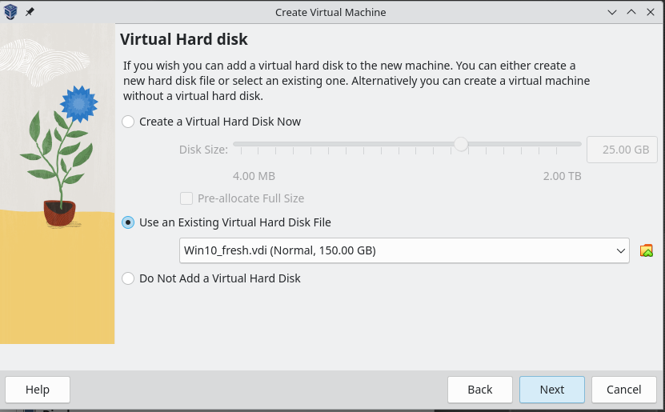This should lead to a window similar to this:

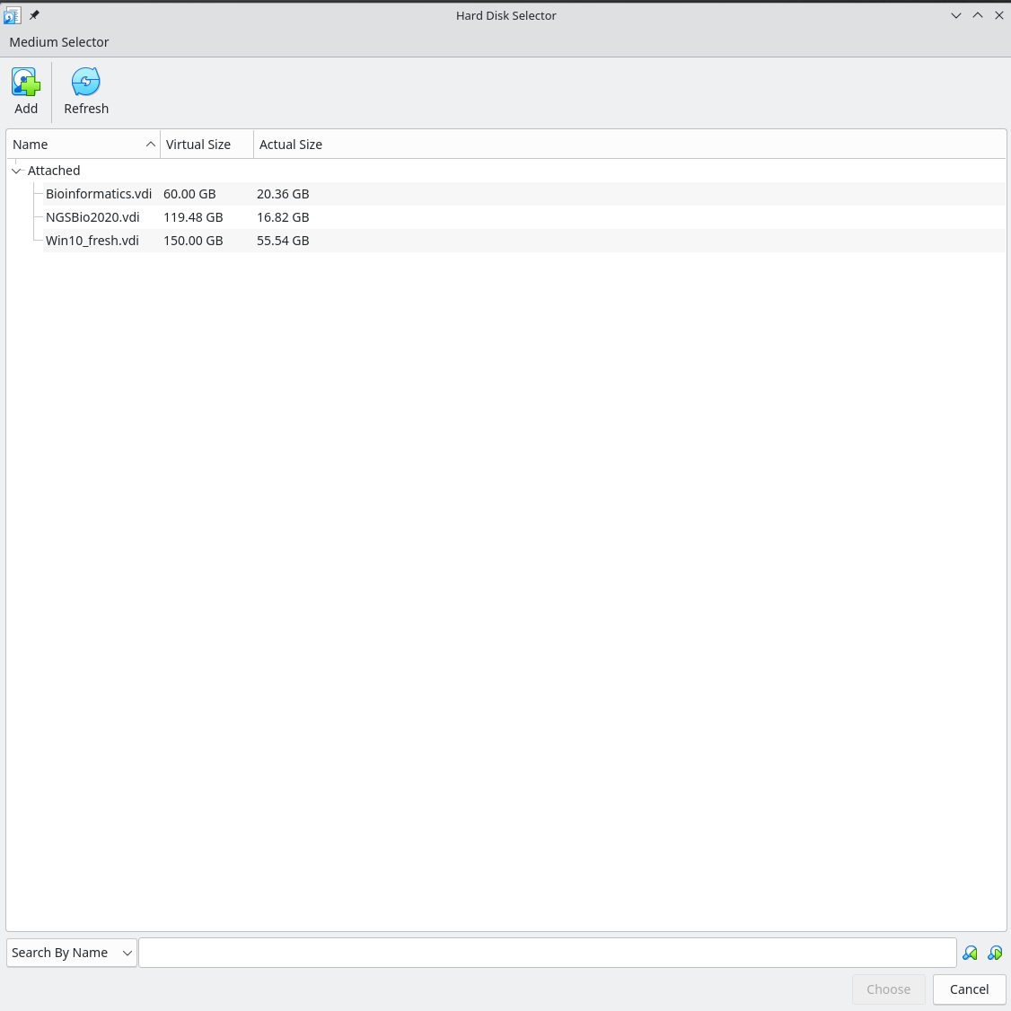

Click the Add button on the top left and choose the .vdi file you downloaded. Highlight it and click Choose.

Finally click ‘Next’ and then ‘Finish’ and you should have a new VM in the list e.g.:

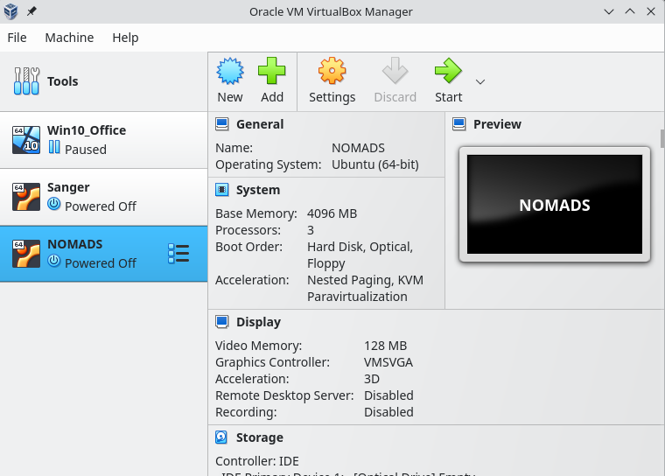

6) All that remains now is to start the virtual machine. On the manager window, highlight your virtual machine’s name and click the ‘Start’ icon. The virtual machine should run through a boot process and, after a short time, give you a start-up window.